Problems are like stairs we have to solve it at every stage of life and thus solving them we can reach to our desired position. Challenges are faced by everyone but the one who overcome it by following proper methods and steps can be successful.
IIC cell and computer engineering department had organised a session on “problem solving and ideation workshop” on 22nd November, 2022 in Upanishad Hall, CE department at L.D. college of engineering. Event started at 2:30pm. Head of Computer Department, Prof. (Dr.) Chirag S. Thaker was the speaker of the event. Prof. and head of IC department, Dr. Manish Thakkar sir and Prof. and head of EC department, Dr.C.H. Vithalani sir were invited as chief guests. Event was coordinated by Asst. Prof., CE department, Prof. Prachi Pancholi ma’am.
Session was of about 90 minutes and approx. 107 students participated along with some faculty members of L.D. college of engineering.

Objectives of the event:

- To introduce students to various problem-solving basics.
- To educate them about what is an idea how different ideas can help to solve a challenge.
- To cultivate design thinking, digital skills and problem analysing skills in them.
After welcoming professors and students, Prof. Prachi pancholi ma’am introduced the topic. Dr. Manish Thakker sir and Dr.C.H. Vithalani sir shared the importance of such events. Then firstly, HOD sir gave a brief information about flow of the event towards ideas and solutions.

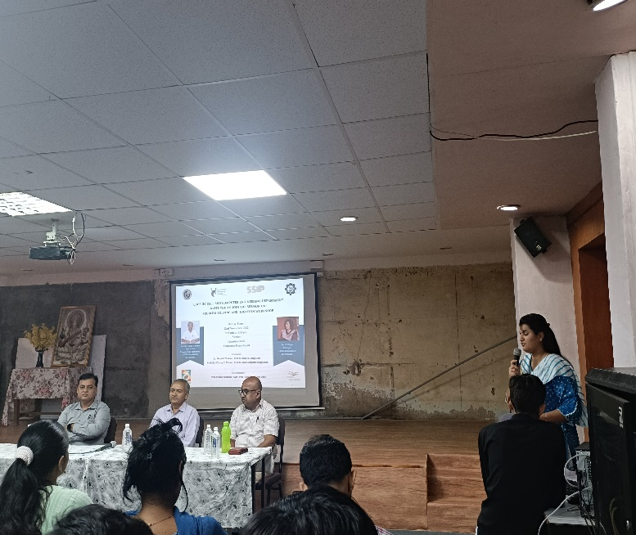
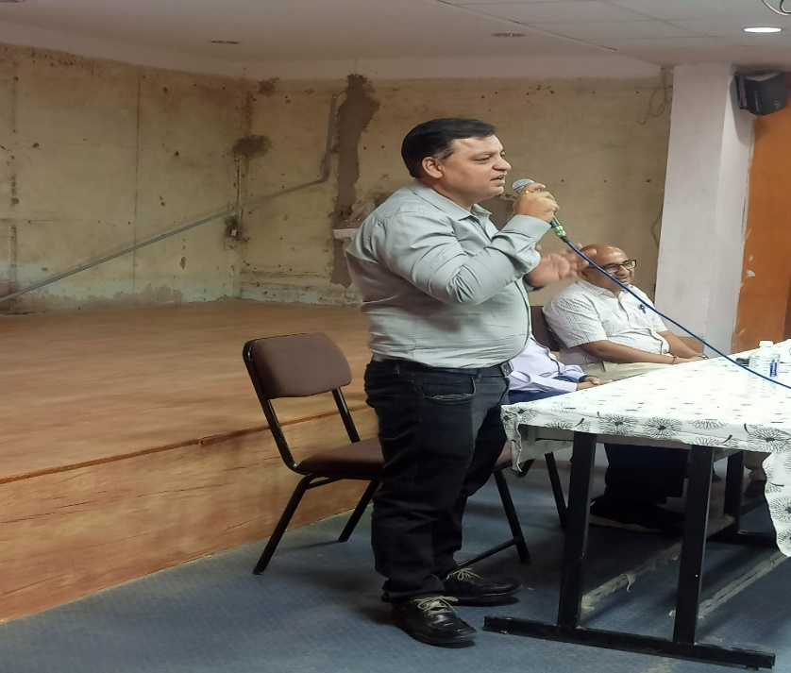
Welcome speech by Prof.Prachi Pancholi Introduction by Prof. (Dr.) Manish sir

Sir presented and shared his thoughts over Innovation Ecosystem and Critical Thinking Skills. He ideated students with stepwise solutions to problems along with real life examples including Apple. He gave broad range of potential solutions to a particular challenge. Then he also explained the importance of innovation, idea generation and how to develop “out of the box thinking” by narrating Toyota’s 7 step problem solving process as a test case.
During the session he also gave many examples of all the big companies like Apple, Alphabet, Amazon, Microsoft, Meta etc. to make sure students better understand the direction of the topic.
He also quoted famous statement of Albert Einstein; “We cannot solve problems by using the same kind of thinking we used to create them.”
Further he quoted, “Every once in a while, a new technology, an old problem and a big idea turns into an innovation.”

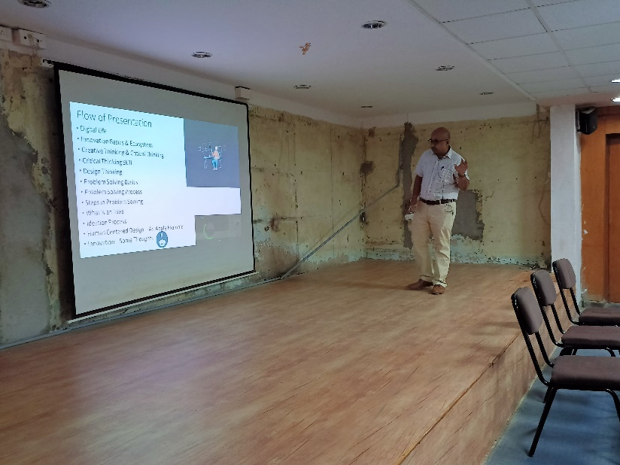
HOD sir explaining flow of presentation

He pointed out some major aspects of problem solving and critical thinking like:
- Problem has to be known first to approach its solution.
- Acknowledgement about ideation and solving steps is must.
- Revenue schemes of many developed companies.
- Outcomes are effective with solution focused mind set.
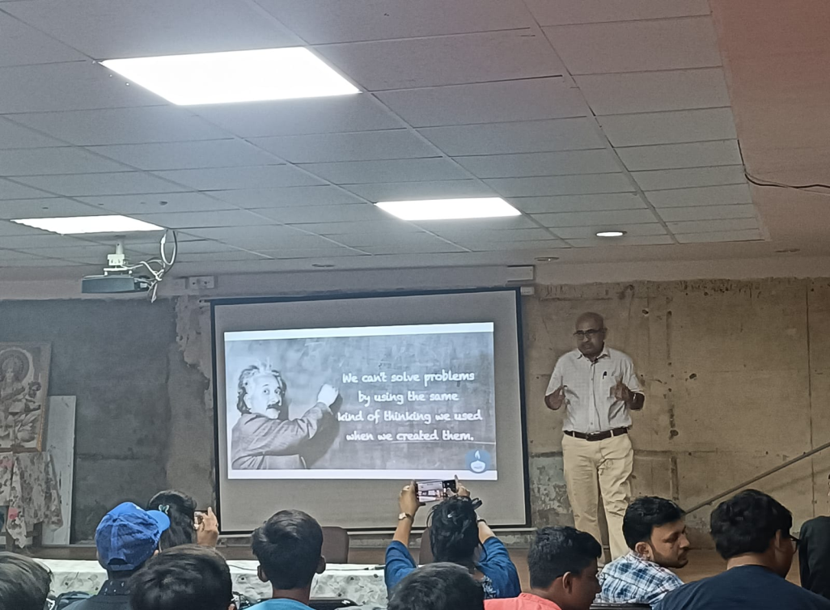
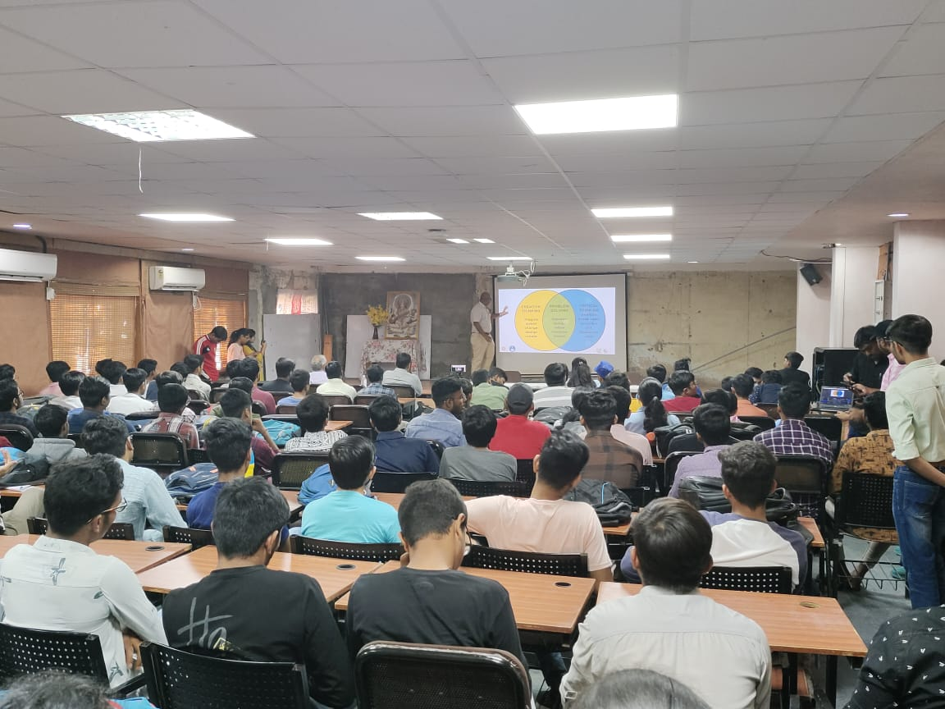
$Type equation here.$
Students actively participating in the event
He explained that ideas are the foremost building blocks before starting to think about any solution. He also pinpointed out many critical sub steps in between the steps of solving process. After that he also stressed creative thinking as a crucial aspect for the same. Further he described that along with all these, going along the steps is also important.
Event concluded with an opportunity for students to explore challenges and their solutions with different ideas and deep approach.
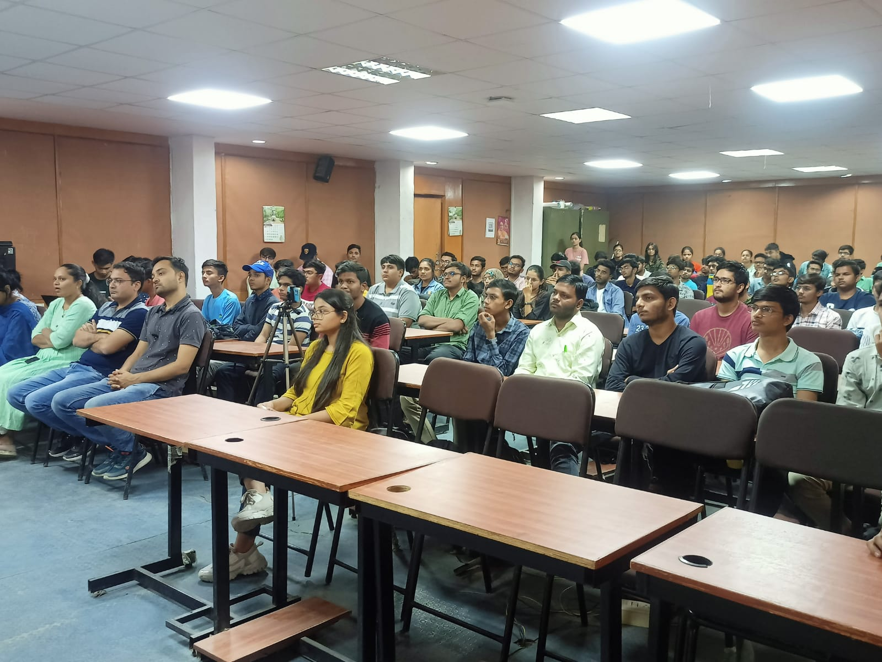

Benefit in terms of knowledge and skills:

- Students were motivated to see the problems thoroughly and try to find solutions to them.
- Students gained many insights about ideation process and how to follow it.
- Students learnt about problem solving ways and innovations of many big tech companies.

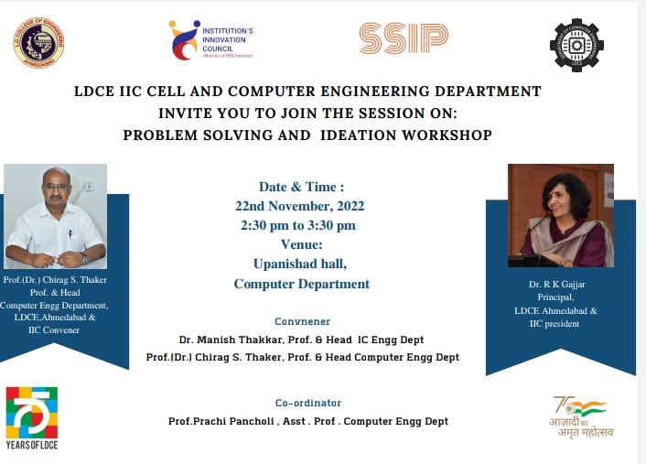
Flyer for the event

